Datasheet for finding GPS location and velocity data from the EarthScope Plate Boundary Observatory website for sites P395, P396 and P404 (https://www.unavco.org/instrumentation/networks/status/pbo/overview/P395 and so on)
Name: ____________________________________________________________
Date on which the data were acquired from the PBO website: _________________________
Geographic coordinates using WGS 1984 datum, North American 2008 Reference Frame (NAM08)
Site Decimal Lat Decimal Long

P395 ______________________ _______________________

P396 ______________________ _______________________

P404 ______________________ _______________________
GPS site velocities relative to NAM08, expressed in mm/year
Site N Velocity ± Uncert E Velocity ± Uncert Height Velocity ± Uncert
P395 __________ _________ __________ _________ __________ _________
P396 __________ _________ __________ _________ __________ _________
P404 __________ _________ __________ _________ __________ _________

Now plot the horizontal velocities on the map on the following page and then answer the following questions.
Use your group’s map of the velocity field to hypothesize (infer) the instantaneous deformation for this set of stations.
Approximate Magnitude (mm/yr) Approximate Azimuth (ex. “north” or “southwest”)
Translation: ________________ ________________
Rotation direction (+ = counter clockwise, - = clockwise): ________________
Strain:
Sign (+ = extension, - = contraction) Approximate Azimuth
Max horizontal extension ________________ ________________
Min horizontal extension ________________ ________________

Carefully draw the E-W and N-S velocity vectors associated with the three PBO GPS sites shown as green dots in the map below. A negative east component is a vector pointing west, and a negative north component is a vector pointing south. The graphs are scaled in units of millimeters per year. Then draw the total horizontal velocity vector for each site, and determine the horizontal speed (that is, the length of the total horizontal velocity vector) of each site. You can determine the total horizontal speed by one of the methods shown at right below.
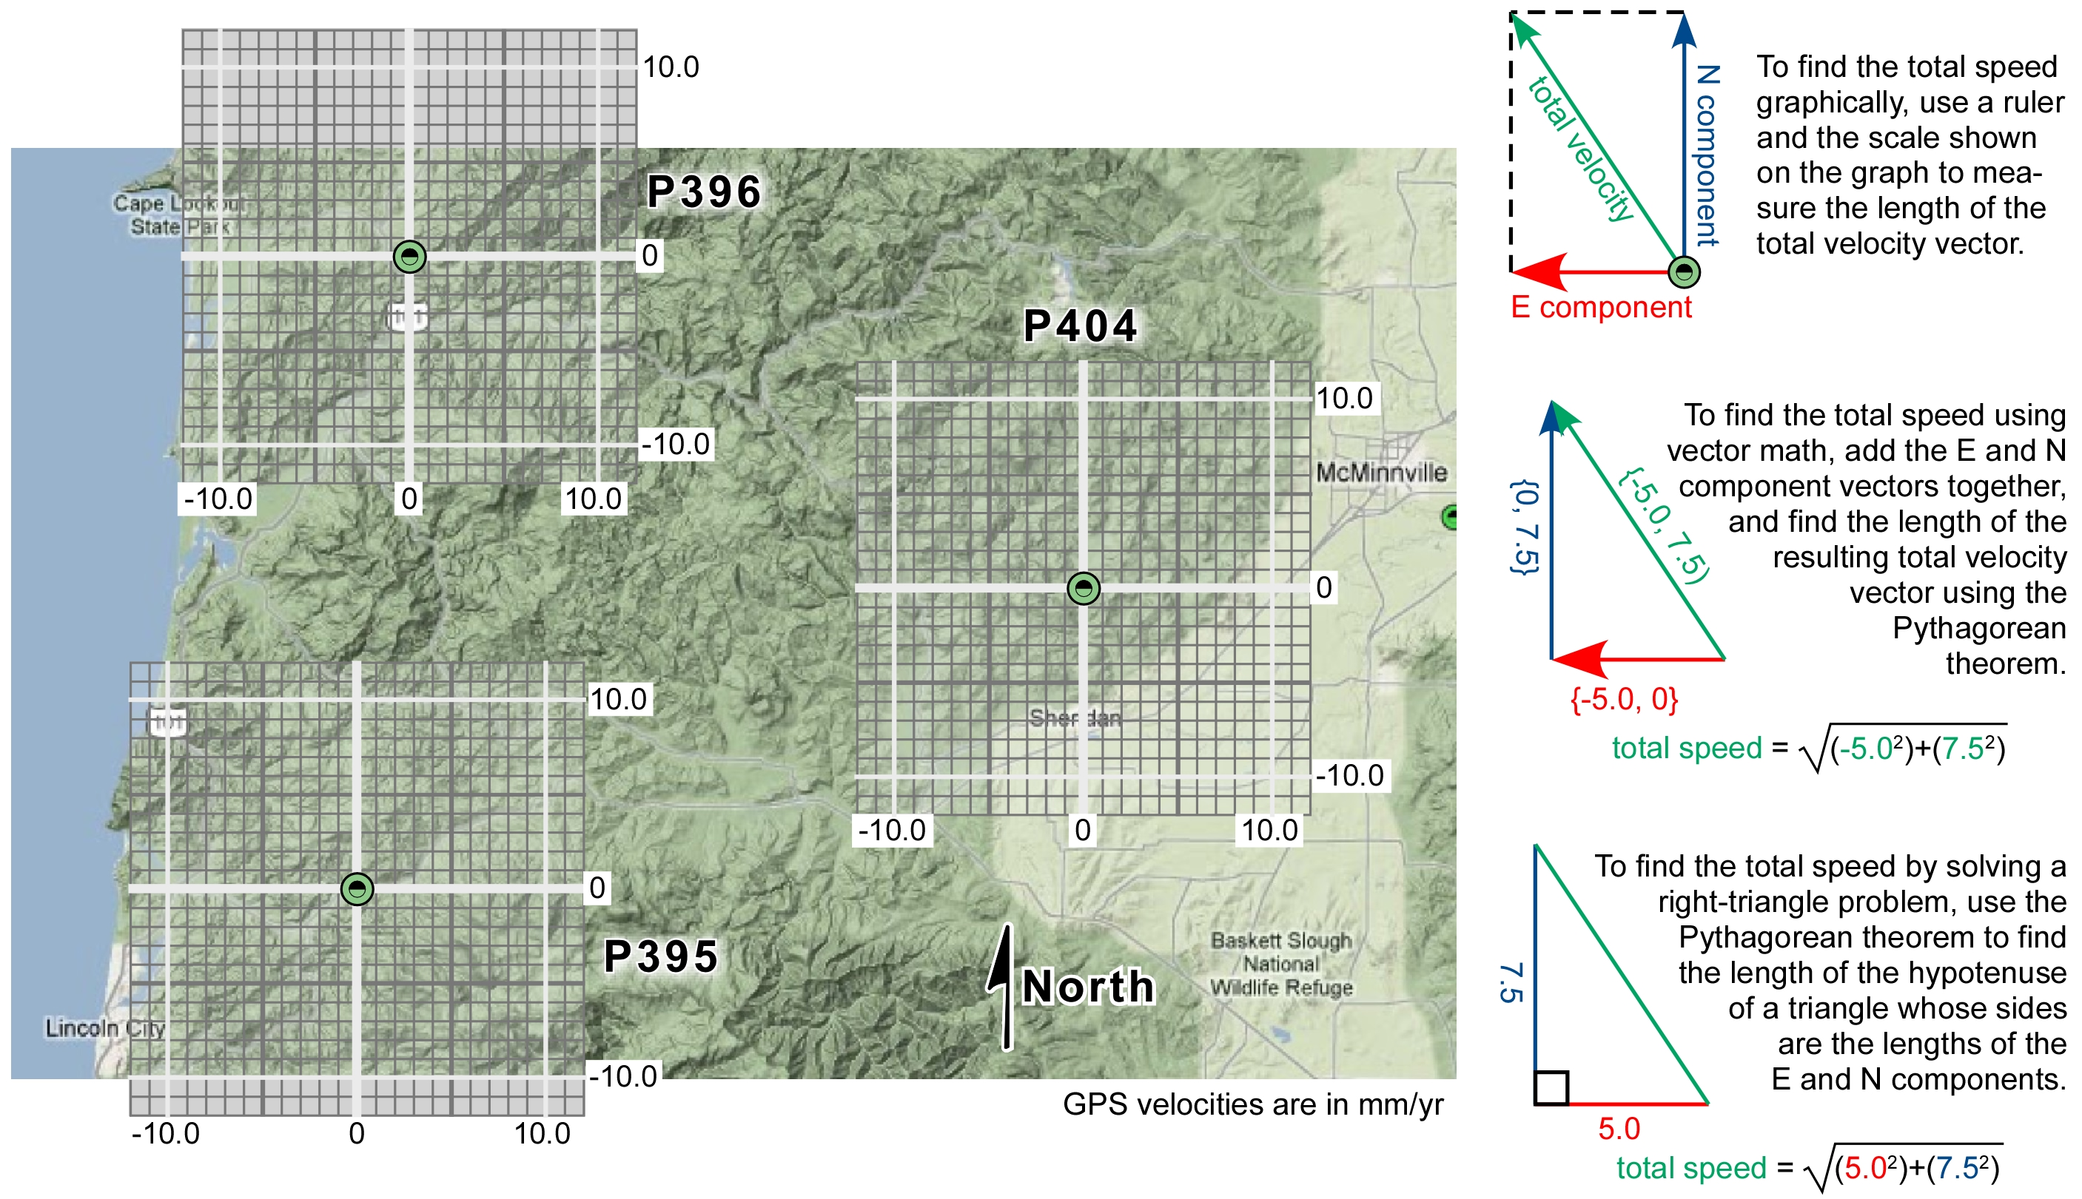
Total horizontal speeds: P395 _______________mm/yr; P396 _______________mm/yr; P404 _______________mm/yr

