GPS strain analysis examples – Student exercise

Example 1: Olympic Peninsula Name:________________________
Please complete the following worksheet to estimate, calculate, and interpret the strain for a triangle defined by three GPS stations at the tip of the Olympic Peninsula, just west of Seattle.

Step 1. Estimate the strain from the velocity field
Use your group’s map of the velocity field to hypothesize (infer) the instantaneous deformation for this set of stations.
Approximate Magnitude (m/yr) Approximate Azimuth
Translation: ________________ ________________
Rotation direction (+ = counter clockwise, - = clockwise): ________________
Strain:
Sign (+ = extension, - = contraction) Approximate Azimuth
Max horizontal extension ________________ ________________
Min horizontal extension ________________ ________________

Step 2. Calculate the instantaneous deformation
Use the strain calculator provided by your instructor to find the following parameters that describe the complete deformation of the area.
E component ± uncert (m/yr) N component ± uncert (m/yr)
Translation Vector __________ _________ __________ _________
Azimuth (degrees) Speed(m/yr)
________________ ________________
magnitude ± uncertainty (deg/yr) magnitude ± uncertainty (nano-rad/yr) direction
Rotation __________ _________ __________ _________ ____________
Magnitude (e1H) (nano-strain) Azimuth of S1H (degrees)
Max horizontal extension ________________ ________________
Magnitude (e2H) (nano-strain) Azimuth of S2H (degrees)
Min horizontal extension ________________ ________________
Max shear strain (nano-strain) ________________
Area strain (nano-strain) ________________

Step 3. Interpret the results
Compare your results to your estimates from Step 1 as well as other indicators of crustal strain including regional tectonics (Fig. OP.1) and active faults (Fig. OP.2). You may find the document Explanation of calculator output and the Strain Ellipse Visualization to be helpful in your interpretation. In order to get the Visualization tool working, download “Wolfram CDF Player” (http://www.wolfram.com/cdf-player/). Once Wolfram is running, open the Strain Ellipse Visualization CDF file. You can input the results from the GPS Strain Calculator and see a highly exaggerated version of the resulting strain ellipse.
Did your estimates in Step 1 generally agree or not with the outputs of the strain calculator? Explain.

The Juan de Fuca plate is moving toward the northeast relative to North America at an azimuth of 59 degrees with a velocity of 0.033 m/yr (UNAVCO Plate Calculator using GSRM v1.2 velocities and fixed North America for a point on the Juan de Fuca plate at 47.055154 degrees latitude and -126.258545 degrees longitude).
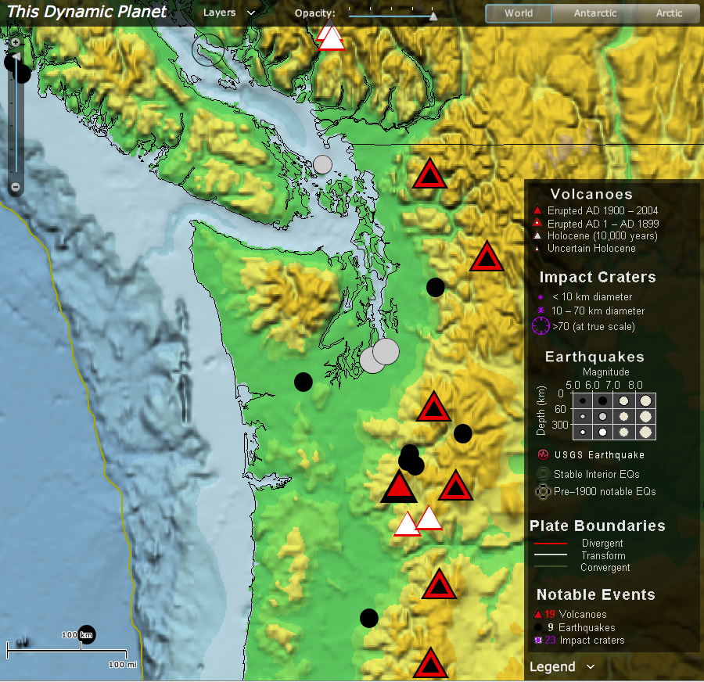
Figure OP.1. Tectonic setting for the Olympic Peninsula. The North American – Juan De Fuca Plate boundary (trench of the Cascadia Subduction zone) is the thin yellow line on the left side of the figure. (This Dynamic Planet (Simkin et al., 2006))

How does the deformation you calculated from GPS velocities compare to the kinematics (motion) of this subduction zone?

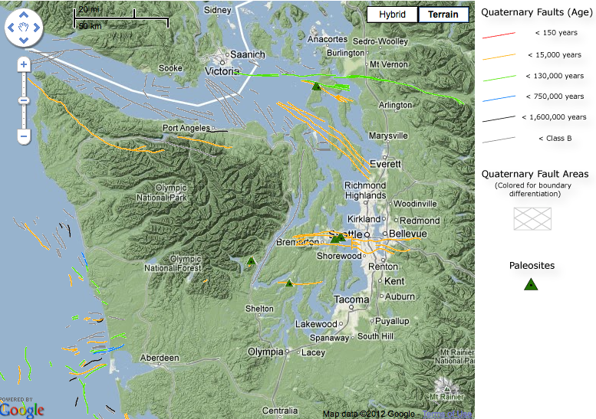
Figure OP.2. Quaternary faults and folds in the region of the Olympic Peninsula (US Geological Survey, 2006)
Although most of the relative motion between the North America and Juan de Fuca plates is accommodated by the plate boundary fault, active faults in the region (Fig. OP.2) attest to some permanent deformation of the overriding plate.
Based on your strain calculations what sort of motion do you expect on the orange faults along the northern margin of the Olympic Peninsula (reverse, normal, left-lateral, right lateral or some combination of these (i.e. oblique slip – specify a combination such as normal + right lateral))?

Step 4. Consider societal impacts of an earthquake
Now that you have calculated the ongoing strain in this region and considered the related tectonic setting, it is time to consider the societal impacts of a large earthquake resulting from this plate motion and strain. Read (skim) Cascadia Subduction Zone Earthquakes: A Magnitude 9.0 Earthquake Scenario, pg. 6, 8-17 and answer the following questions:
- What is the expected economic loss from the earthquake?
- What are the anticipated deaths from the earthquake?
- How are transportation systems likely to be effected?
- What is a consequence of a Cascadia subduction earthquake that you think may be relatively unique compared to earthquakes in the other regions your classmates are looking at?
- Select one societal consequence that you have identified for this earthquake and propose a possible mitigation strategy and challenge for implementing it.
- How might infinitesimal strain analysis be used as a component of earthquake hazard assessment?

Example 2: Wasatch Front Name:________________________
Please complete the following worksheet to estimate, calculate, and interpret the strain for a triangle defined by three GPS stations that span the Wasatch Mountain Front in the Salt Lake City metropolitan area (Fig. WF.1).

Step 1. Estimate the strain from the velocity field
Use your map of the velocity field to hypothesize (infer) the instantaneous deformation for this set of stations.
Approximate Magnitude (m/yr) Approximate Azimuth
Translation: ________________ ________________
Rotation direction (+ = counter clockwise, - = clockwise): ________________
Strain:
Sign (+ = extension, - = contraction) Approximate Azimuth
Max horizontal extension ________________ ________________
Min horizontal extension ________________ ________________

Step 2. Calculate the instantaneous deformation
Use the strain calculator provided by your instructor to find the following parameters that describe the complete deformation of the area.
E component ± uncert (m/yr) N component ± uncert (m/yr)
Translation Vector __________ _________ __________ _________
Azimuth (degrees) Speed(m/yr)
________________ ________________
magnitude ± uncertainty (deg/yr) magnitude ± uncertainty (nano-rad/yr) direction
Rotation __________ _________ __________ _________ ____________
Magnitude (e1H) (nano-strain) Azimuth of S1H (degrees)
Max horizontal extension ________________ ________________
Magnitude (e2H) (nano-strain) Azimuth of S2H (degrees)
Min horizontal extension ________________ ________________
Max shear strain (nano-strain) ________________
Area strain (nano-strain) ________________

Step 3. Interpret the results
You may find the document Explanation of calculator output and the Strain Ellipse Visualization to be helpful in your interpretation. In order to get the Visualization tool working, download “Wolfram CDF Player” (http://www.wolfram.com/cdf-player/). Once Wolfram is running, open the Strain Ellipse Visualization CDF file. You can input the results from the GPS Strain Calculator and see a highly exaggerated version of the resulting strain ellipse.
Did your estimates in Step 1 generally agree or not with the outputs of the strain calculator? Explain.

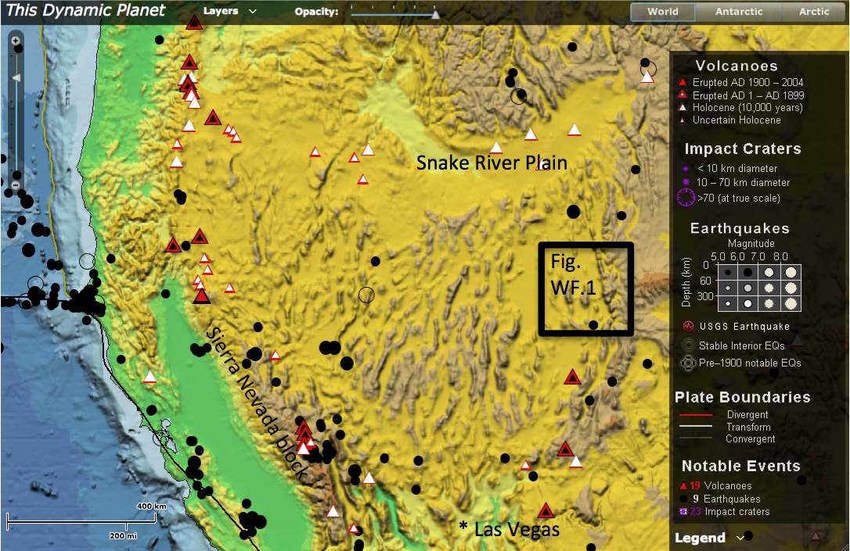
The Pacific plate is moving toward the northwest relative to North America at an azimuth of 323 degrees with a velocity of 0.049 m/yr (UNAVCO Plate Calculator using GSRM v1.2 velocities and fixed North America for a point on the Pacific plate located at 37.696318 degrees latitude and -123.009224 degrees longitude). Most of this motion is accommodated by slip along the San Andreas Fault, but deformation in the Basin and Range province contributes a significant component of westward motion.
Figure WF.1. Tectonic setting for the Wasatch Front. The mountain front marks the eastern edge of the northern Basin and Range tectonic province that extends westward to the Sierra Nevada block, northward to the Snake River Plain and southward to Las Vegas. (This Dynamic Planet (Simkin et al., 2006))

How does the deformation you calculated from GPS velocities compare to the kinematics (motion) of the Basin and Range?

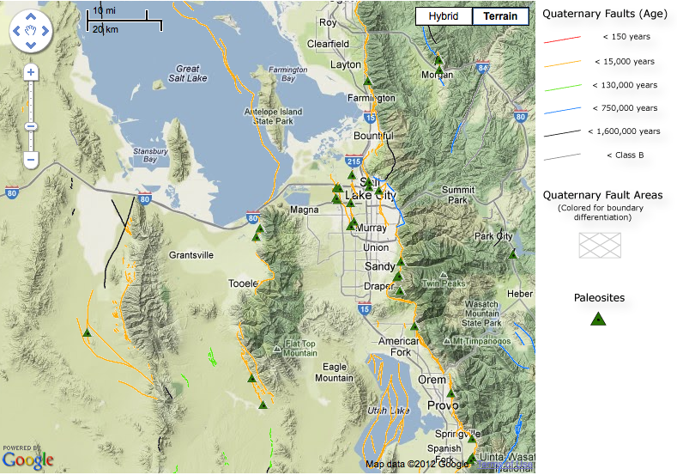
Figure WF.2. Quaternary faults and folds in the vicinity of the Wasatch Front near Salt Lake City (US Geological Survey, 2006)
The Basin and Range province is named after the numerous mountain ranges separated by intervening basins. In the Salt Lake City area the ranges are bounded on their western sides by active faults (Fig. WF.2).
Based on your strain calculations what sort of motion do you expect on these orange range-bounding faults (reverse, normal, left-lateral, right lateral or some combination of these (i.e. oblique slip – specify a combination such as normal + right lateral))?

Step 4. Consider societal impacts of an earthquake
Now that you have calculated the ongoing strain in this region and considered the related tectonic setting, it is time to consider the societal impacts of a large earthquake resulting from this plate motion and strain. Search HAZUS-MH: Earthquake Event Report for Provo Segment Mw 7.2 ShakeMap Scenario for answers to the following questions:
- What is the expected economic loss from the earthquake? (search for “economic loss”)
- What are the anticipated deaths from the earthquake? (search for “deaths”)
- How are transportation systems likely to be effected?
- What is a consequence of a Wasatch earthquake that you think may be relatively unique compared to earthquakes in the other regions your classmates are looking at?
- Select one societal consequence that you have identified for this earthquake and propose a possible mitigation strategy and challenge for implementing it.
- How might infinitesimal strain analysis be used as a component of earthquake hazard assessment?

Example 3: San Andreas Fault Name:________________________
Please complete the following worksheet to estimate, calculate, and interpret the strain for a triangle defined by three GPS stations that span the central San Andreas Fault southwest of the town of Parkfield (Fig. SA.1).

Step 1. Estimate the strain from the velocity field
Use your map of the velocity field to hypothesize (infer) the instantaneous deformation for this set of stations.
Approximate Magnitude (m/yr) Approximate Azimuth
Translation: ________________ ________________
Rotation direction (+ = counter clockwise, - = clockwise): ________________
Strain:
Sign (+ = extension, - = contraction) Approximate Azimuth
Max horizontal extension ________________ ________________
Min horizontal extension ________________ ________________

Step 2. Calculate the instantaneous deformation
Use the strain calculator to find the following parameters that describe the complete deformation of the area.
E component ± uncert (m/yr) N component ± uncert (m/yr)
Translation Vector __________ _________ __________ _________
Azimuth (degrees) Speed(m/yr)
________________ ________________
magnitude ± uncertainty (deg/yr) magnitude ± uncertainty (nano-rad/yr) direction
Rotation __________ _________ __________ _________ ____________
Magnitude (e1H) (nano-strain) Azimuth of S1H (degrees)
Max horizontal extension ________________ ________________
Magnitude (e2H) (nano-strain) Azimuth of S2H (degrees)
Min horizontal extension ________________ ________________
Max shear strain (nano-strain) ________________
Area strain (nano-strain) ________________

Step 3. Interpret the results
Compare your results to your estimates from Step 1 as well as other indicators of crustal strain including regional tectonics (Fig. OP.1) and active faults (Fig. OP.2). You may find the document Explanation of calculator output and the Strain Ellipse Visualization to be helpful in your interpretation. In order to get the Visualization tool working, download “Wolfram CDF Player” (http://www.wolfram.com/cdf-player/). Once Wolfram is running, open the Strain Ellipse Visualization CDF file. You can input the results from the GPS Strain Calculator and see a highly exaggerated version of the resulting strain ellipse.
Did your estimates in Step 1 generally agree or not with the outputs of the strain calculator? Explain.

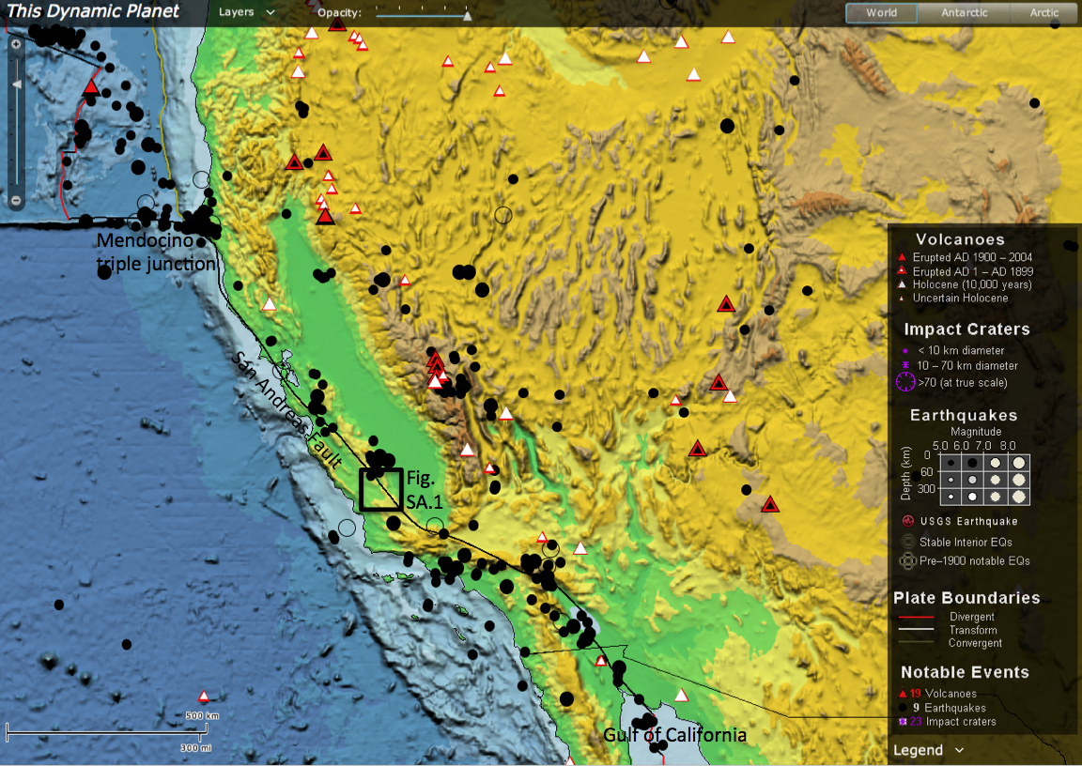
The Pacific plate is moving toward the northwest relative to North America at an azimuth of 323 degrees with a velocity of 0.49 m/yr (UNAVCO Plate Calculator using GSRM v1.2 velocities and fixed North America for a point on the Pacific plate located at 37.696318 degrees latitude and -123.009224 degrees longitude). Most of this motion is accommodated by slip along the San Andreas Fault.
Figure SA.1. Tectonic setting for the San Andreas Fault. The San Andreas Fault (thin black line) forms the western boundary of the North American plate from the Gulf of California to the Mendocino triple junction (This Dynamic Planet (Simkin et al., 2006)).

How does the deformation you calculated from GPS velocities compare to the kinematics (motion) of the plate boundary?

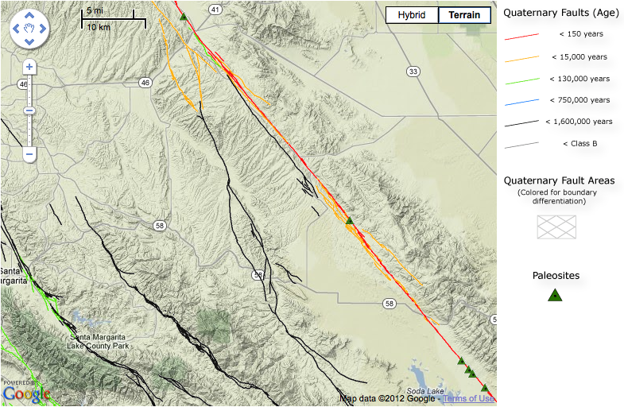
Figure SA.2. Quaternary faults and folds in the vicinity of the central San Andreas. The active trace of the San Andreas Fault is shown in red (US Geological Survey, 2006).
The San Andreas Fault in this area slipped 3-9 meters during the 1857 Ft. Tejon earthquake.
Based on your strain calculations what sort of slip do you expect occurred along this segment of the San Andreas Fault (reverse, normal, left-lateral, right lateral or some combination of these (i.e. oblique slip – specify a combination such as normal + right lateral)) during the earthquake?

Step 4. Consider societal impacts of an earthquake
Now that you have calculated the ongoing strain in this region and considered the related tectonic setting, it is time to consider the societal impacts of a large earthquake resulting from this plate motion and strain. Read (skim) the USGS San Andreas Mag 7.8 Earthquake ShakeOut Scenario, pg 2-10, 94-95 for answers to the following questions:
- What is the expected economic loss from the earthquake?
- What are the anticipated deaths from the earthquake?
- How are transportation systems likely to be effected?
- What is a consequence of a San Andreas earthquake that you think may be relatively unique compared to earthquakes in the other regions your classmates are looking at?
- Select one societal consequence that you have identified for this earthquake and propose a possible mitigation strategy and challenge for implementing it.
- How might infinitesimal strain analysis be used as a component of earthquake hazard assessment?

Selected References

General
Simkin, T., Tilling, R.I., Vogt, P.R., Kirby, S.H., Kimberly, P., and Stewart, D.B., 2006, This dynamic planet: World map of volcanoes, earthquakes, impact craters, and plate tectonics: U.S. Geological Survey Geologic Investigations Series Map I-2800, 1 two-sided sheet, scale 1:30,000,000, accessed 11/21/2012, from Smithsonian web site: URL: http://mineralsciences.si.edu/tdpmap/.
U.S. Geological Survey, 2006, Quaternary fault and fold database for the United States, accessed 11/21/2012, from USGS web site: http//earthquakes.usgs.gov/regional/qfaults/

Example 1
Chapman, James S. and Melbourne, T., 2009, Future Cascadia megathrust rupture delineated by episodic tremor and slip: Geophysical Research Letters, v. 36, L22301.
Johnson, Samuel Y., Potter, Christopher J., and Armentrout, John M., 1994, Origin and evolution of the Seattle fault and Seattle basin, Washington: Geology, v. 22, p. 71-74.
Lidke, D.J., compiler, 2004, Fault number 550, Calawah fault, in Quaternary fault and fold database of the United States: U.S. Geological Survey website, http://earthquakes.usgs.gov/regional/qfaults, accessed 11/21/2012.

Example 2
Black, B.D., DuRoss, C.B., Hylland, M.D., McDonald, G.N., and Hecker, S., compilers, 2004, Fault number 2351f, Wasatch fault zone, Salt Lake City section, in Quaternary fault and fold database of the United States: U.S. Geological Survey website, http://earthquakes.usgs.gov/hazards/qfaults, accessed 01/02/2013 09:10 AM.
Chang, W.L. and Smith, R.B., 2002, Integrated seismic-hazard analysis of the Wasatch Front, Utah: Bulletin of the Seismological Society of America, v. 92, p. 1904-1922.
Elósegui, P., Davis, J.L., Mitrovica, J. X., Bennett, R. A., and Wernicke, B. P., 2003, Crustal loading near Great Salt Lake, Utah: Geophysical Research Letters, v. 30, 1111 doi:10.1029/2002GL016579.
Hammond, W.C. and Thatcher, W., 2004, Contemporary tectonic deformation of the Basin and Range province, western United States: 10 years of observation with the global positioning system: Journal of Geophysical Research, v. 109, B08403, doi:10.1029/2003JB002746.
Parsons, T. and Thatcher, W., 2011, Diffuse Pacific-North American plate boundary: 1000 km of dextral shear inferred from modeling geodetic data: Geology, V. 39, p. 943-946.

Example 3
Bryant, W.A., and Lundberg, M.Matthew, compilers, 2002, Fault number 1g, San Andreas fault zone, Cholame-Carrizo section, in Quaternary fault and fold database of the United States: U.S. Geological Survey website, http://earthquakes.usgs.gov/hazards/qfaults, accessed 01/02/2013 10:52 AM.
Sieh, K.E. and Jahns, R.H., 1984, Holocene activity of the San Andreas Fault at Wallace Creek, California: Geological Society of America Bulletin, V. 95, p. 883-896.

