Algorithm for computing infinitesimal strain rate between three non-colinear GPS stations, given their N-S and E-W velocities, with a worked example

Introduction. This algorithm explains how to compute the mean infinitesimal horizontal strain (or instantaneous horizontal strain rate) in the crust between three GPS sites. The theory on which this algorithm is based is presented in the instantaneous strain primer that accompanies this module. This algorithm is implemented in strain calculators written in Excel, Mathematica and MatLab.

The analysis described in this document involves several assumptions. All significant strain is assumed to occur in the horizontal plane, so no vertical velocities are used. One of the principal strain axes is assumed to be vertical. Deformation is assumed to be homogeneous across the area between the three GPS sites. In the description of the worked example, no attempt is made to round values to the appropriate significant figures until the end of the analysis.
____________________
Step 1. Acquire location and velocity data for three GPS stations that form a triangle in which none of the interior angles is less than ~30°. Usually, the location of GPS stations is expressed in geographic coordinates (latitude and longitude). To be compatible with the following explanation, the location data should be converted to UTM coordinates within the same UTM zone, and the velocity data should consist of N-S and E-W vectors with magnitudes expressed in m/yr relative to a stable-North-America reference fame such as NAM08. If the stations straddle a zone boundary, it is best to compute the coordinates of the site(s) in the eastern zone as if they were in the western zone. You can use the web-based conversion utility offered by the National Geodetic Survey via https://www.ngs.noaa.gov/NCAT/ . Alternatively, the Excel spreadsheet "gps_strain_calculator_excel.v3.xls" (available via https://d32ogoqmya1dw8.cloudfront.net/files/getsi/teaching_materials/gps_strain/gps_strain_calculator_excel.v3.xls) implements code in rows 41-88 that is patterned after a conversion spreadsheet by Steven Dutch that converts from geographic coordinates (WGS84) to UTM (or vice versa).

Site UTM easting UTM northing E velocity Uncert N velocity Uncert
No. (meters) (meters) (m/year) (m/year) (m/year) (m/year)
P146 712245.807 4357118.796 -0.01031 0.00001 0.00625 0.00001
P149 748566.739 4387604.015 -0.00942 0.00003 0.00520 0.00003
P150 755806.255 4353418.458 -0.01086 0.00003 0.00592 0.00003
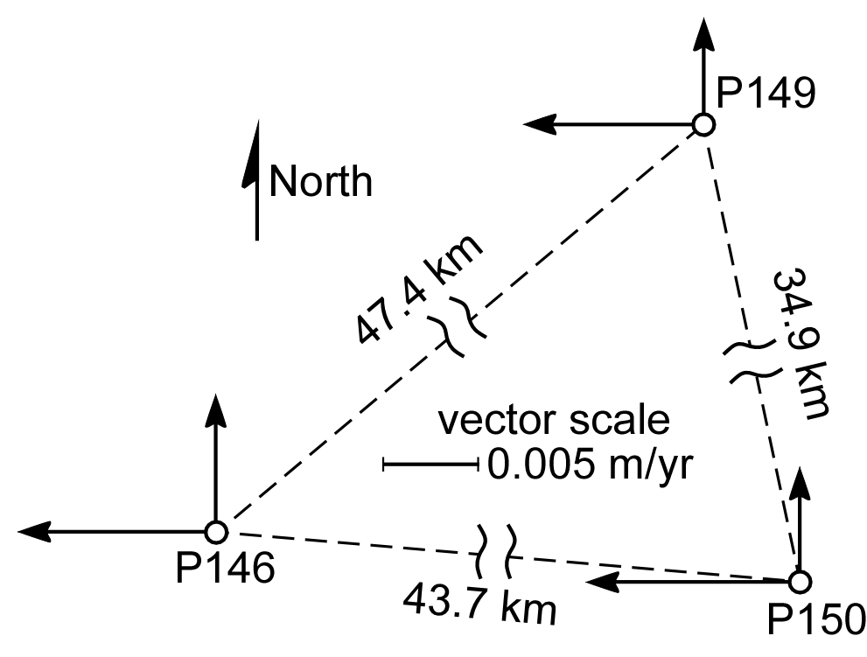
Figure 1. Map of 3 non-colinear GPS sites, part of the Plate Boundary Observatory. The east-west and north-south velocities of each site relative to the Stable North American Reference Frame are indicated by arrows.
Step 2. Find the center of the triangle formed by the three GPS stations. The x (east-west) coordinate of the triangle center is the sum of the three x coordinates divided by 3. In this example, we have
The y (north-south) coordinate is the sum of the three y coordinates divided by 3. For this example,
____________________
Step 3. Transform the three points into a coordinate system in which the center of the triangle has the {x, y} coordinates {0, 0}. To do this, subtract the coordinates of the center of the triangle from the coordinates of each of the stations. The transformed coordinates of the three stations are as follows:
station 146 : {(712245.8 - 738872.9), (4357118.8 - 4366047.1)} = {-26627.1, -8928.3}
station 149 : {(748566.261 - 738872.9), (4387604.0 - 4366047.1)} = {9693.8, 21556.9}
station 150 : {(755806.266 - 738872.9), (4353418.5 - 4366047.1)} = {16933.4, -12628.6}
The reason for this step, which was suggested by J.C. Savage, is that the translation vector that we will soon compute relates to the translation of the origin of the coordinate system. It is simply more meaningful to compute the translation of the center of the area we are studying than to compute the translation of the origin of the UTM grid we are in, which in this case is more than 700 km west and 4,350 km south of our area of interest.
____________________

Step 4. Make a matrix called m1 in which the x (east-west) coordinates of the GPS sites form the first column, and the y (north-south) coordinates form the second column. In our example, the first row is formed by the Cartesian coordinates of GPS site 146, expressed in UTM coordinates.
m1 =
Rather than keep typing those long numbers, we can refer to the value "-12628.6" in row 3, column 2 of matrix m1 using subscripts: m1₃₂.
____________________
Step 5. Use the values in matrix m1 to fill-in the values in matrix m2 that are not filled with 0s and 1s, as defined by the following:
m2 =
So, in this example, the matrix m2 would look like this if we wrote-in the actual values.
m2 =
Note that matrix m2 is a square matrix, which means that it has the same number of columns as rows.
____________________
Step 6. Invert matrix m2 to form matrix m3.
m3 = m2⁻¹
This can be done by hand, but frankly you would be a little bit nuts to do so.
• In Microsoft Excel, there is a function called MINVERSE (for Matrix INVERSE) that will invert a square matrix. While your computer is connected to the web and Excel is open, select Excel Help from the Help menu, and type MINVERSE in the search box. An explanation for the MINVERSE function from the Help Center will appear, and illustrate how to use the function in your version of Excel. The utube video at http://www.youtube.com/watch?v=G8w-d9U3PJM might also be helpful.
• The command to invert a square matrix m2 in MatLab is inv(m2) (see http://www.mathworks.com/help/techdoc/ref/inv.html).
• The command to invert a square matrix m2 in Mathematica is Inverse[m2] (see http://reference.wolfram.com/mathematica/ref/Inverse.html and http://www.wolframalpha.com/examples/Matrices.html).
• You might find a matrix calculator online that will provide you with the result you need.
In this example, matrix m3 looks like this:
m3 =
____________________
Step 7. Create a column matrix called m4 that contains the velocity data for the three GPS sites, as shown below:
m4 =
In the matrix above, ^{P146}v_{x} is the east velocity of PBO site P146 in m/yr, and ^{P146}v_{y} is the north velocity of that site. Matrix m4 is a 6x1 column matrix – it has 6 rows and 1 column.
____________________
Step 8. Multiply matrix m4 by matrix m3 to yield a 6x1 column matrix called m5.
m5 = m3 m4 =

Step 9. Find the infinitesimal translation vector for the triangle defined by the three GPS stations, as measured in the Stable North American Reference Frame (SNARF). The first two values of matrix m5 (that is, the values in the first two rows of m5, or m5₁₁ and m5₂₁) are the coordinates of the mean translational velocity vector of the sites.
translational vector = {t_{x}, t_{y}} = { m5₁₁, m5₂₁}
In this example,
translational vector = {-0.0101967, 0.00579}.
The length of the translation vector is the translational speed in meters per year, which we can find using the Pythagorean Theorem.
translational speed =
In this example,
translational speed = = 0.0117259 m/yr
The x coordinate of the translation vector has a negative value, so the vector is directed toward the west rather than toward the east. The y coordinate has a positive value, so the vector is directed toward the north rather than toward the south. To find the azimuth of the translation vector, we must first find the angle between the translation vector and a unit vector that is pointing due north, which would have coordinates {0, 1}. (A unit vector is a vector that has a length of 1.)
unit north vector = = {0, 1}
We can find the unit vector that is coincident with the translation vector by dividing each coordinate of the translation vector by the translational speed. In this example,
unit translation vector = =
unit translation vector = {-0.869587, 0.49378}
To find the angle in degrees between the north vector and the unit translation vector, take the inverse cosine (or arc cosine or cos⁻¹) of the dot product of the two unit vectors, and multiply the result by the conversion factor from radians to degrees: (180°/π).
=
In this example, θ₁ = ~60.41°. Then we use θ₁ to find the azimuth of the translation vector. If the value of the x coordinate of the translation vector (t_{x}) is a negative number, we subtract θ₁ from 360° to yield the azimuth. If t_{x} is not a negative number, the azimuth is simply equal to θ₁.
In this example, t_{x} is a negative number, so the azimuth of the translation vector is
360° - θ₁ = 360° - 60.41° = ~300°.
We had already determined that the translation vector would be directed toward the north and west, so an azimuth between 270° and 360° makes sense. The centroid of our triangle of GPS stations is translating toward ~300° at a rate of 0.0117259 meters per year.
____________________
Step 10. Find the value of the rotational velocity, Ω, in matrix m5: the value in m5₃₁.
Ω = -2.4854x10⁻⁸ radian per year.
This is the rate at which the principal axes of strain are rotating relative to the original orientation of those lines. In the more convenient units of nano-radian per year, the rotational velocity is
Ω = -24.8541 nano-radian per year.
The negative value for Ω indicates that the axes of the strain ellipse (and lines of material particles that coincided with the principal strain axes prior to deformation) are rotating in a clockwise direction.
____________________
Step 11. Define the 2-D Lagrangian strain tensor (ε) and call it matrix m6.
, so
m6
In this example,
m6 .
____________________
Step 12. Determine the orientations of the principal infinitesimal strain axes by finding the eigenvectors of the symmetrical Lagrangian infinitesimal strain tensor m6. Determine the magnitudes of the principal infinitesimal extensions by finding the eigenvalues (the magnitudes of the eigenvectors) of the Lagrangian strain tensor.
Explanations of how to determine eigenvectors and eigenvalues are plentiful in books on tensors and on the web. Two good sources of information are http://mathworld.wolfram.com/ Eigenvalue.html and http://controls.engin.umich.edu/wiki/index.php/EigenvaluesEigenvectors.
• If you are using MatLab, a general explanation of the process is available online via http://www.mathworks.com/help/techdoc/ref/eig.html and http://www.mathworks.com/help/ techdoc/math/f4-2852.html. If you supply two output variables (e.g., V for a matrix of eigenvectors and D for a matrix in which the corresponding eigenvalues are along the diagonal of a square matrix), MatLab will return eigenvalues and the eigenvectors as unit vectors: [V,D]=eig(m6).
• If you are using Mathematica, you input the following command to acquire the eigenvectors of matrix m6: Eigenvectors[m6]. The unit vectors that coincide with the principal strain axes will be returned in order of descending magnitude, so the vector associated with the eigenvalue with the largest absolute value will be listed first. To find the eigenvalues of m6 in Mathematica, input Eigenvalues[m6]. Or just type EigenSystem[m6] and the output will be a list in which the first group of elements are the eigenvalue, followed by the unit vectors that coincide with the eigenvectors.
• Microsoft Excel does not have a built-in function to find eigenvectors or eigenvalues. Some plug-ins that can compute eigenvalues and eigenvectors are advertised by third-party developers on the web.
One work-around is to use the eigensystem calculator from Wolfram Alpha, available online via http://www.wolframalpha.com/entities/calculators/eigenvalue_calculator/gv/9h/bi/ or http://www.wolframalpha.com/widgets/view.jsp?id=ca851e9f71b25d2d588b7e0d4de3d627.
The Excel spreadsheet "gps_strain_calculator_excel.v3.xls" (available via https://d32ogoqmya1dw8.cloudfront.net/files/getsi/teaching_materials/gps_strain/gps_strain_calculator_excel.v3.xls) implements code in rows 155-162 that determine the unit eigenvectors associated with e₁ and e₂, respectively, in a horizontal plane aligned with the geographic coordinates (+Y is toward north, +X is toward east). The explanation of the relationships implemented in that code is explained in the following text.

In the 2D case in which the strain matrix is a 2x2 matrix, the eigenvalues are the results of the following expressions
with the greater value corresponds to the greater principal extension e₁ along the greater instantaneous horizontal strain axis S_{1H}. The smaller eigenvalue is the lesser principal extension e₂ along the lesser instantaneous horizontal strain axis S_{2H}. In this example,
e₁ = 6.6663 x 10⁻¹⁰, and
e₂ = -3.2961 x 10⁻⁸
Use one of the techniques mentioned above to find the corresponding eigenvectors. In this example, the unit vector that coincides with the greater principal strain axis is
= {-0.8404, -0.5420}
To find the angle θ₂ in degrees between the unit north vector () and the unit vector that coincides with the greater principal strain axis (), take the inverse cosine of the dot product of the two unit vectors, and multiply the result by the conversion factor from radians to degrees: (180°/π).
θ₂ =
In this example, θ₂ = ~123°. Then we use θ₂ to find the azimuth of the S_{1H} axis. If the value of the x coordinate of the S₁ eigenvector is a negative number, we subtract θ₂ from 360° to yield the azimuth. If it is not a negative number, the azimuth is simply equal to θ₂. In this example, the x coordinate of the S₁ eigenvector is a negative number, so
azimuth S_{1H} axis = 360° - θ₂ = 360° - 123° = ~237°.
The S_{1H} axis will trend toward ~237° (or 57°), and the S_{2H} axis will be 90° from S_{1H}, trending 327° (or 147°).
____________________
Step 13. Determine the magnitude of the maximum infinitesimal shear strain (γ_{max}) at 45° to the maximum principal strain axis. Maximum infinitesimal shear strain is given by the following
γ_{max} =
γ_{max} =
In this example,
γ_{max} =
The maximum infinitesimal shear strain is 3.3628x10⁻⁸. There are two other ways of computing the maximum shear strain. The difference between principal extensions e₁ and e₂ is equal to the maximum shear strain. In this example, the difference between e₁ and e₂ is
e₁ – e₂ = (6.6663x10⁻¹⁰) – (-3.2961x10⁻⁸) = 3.3628x10⁻⁸
The principal stretches (S₁ and S₂) are given by
S₁ = 1 + e₁, and
S₂ = 1+ e₂.
The quadratic elongations λ₁ and λ₂ are given by
λ₁ = S₁² = (1 + e₁)² and λ₂ = S₂² = (1 + e₂)²
Finally, the maximum infinitesimal shear strain is given by
γ_{max} =
All three methods give us the same answer: 3.3628x10⁻⁸ or 33.628 nano-strain.
____________________
Step 14. Determine the areal strain rate between the GPS sites. A unit circle (i.e., a circle with a radius of 1) located within the triangle prior to deformation will be an ellipse after deformation. The change in area between the circle and ellipse, divided by the area of the circle, is the area strain. The greater principal stretch (S₁ = 1 + e₁) is the major axis of the ellipse, while the lesser principal stretch (S₂ = 1 + e₂) is the minor axis.
circle area = π
ellipse area = π S₁ S₂
area strain = (ellipse area – circle area)/circle area
In this example, the equation above yields an answer of -3.2295x10⁻⁸. Another way of computing the areal strain is
area strain = (S₁ S₂) – 1
In this example, the equation above yields the same answer as the first equation: -3.2295x10⁻⁸. The area strain is also equal to the first invariant of the strain tensor. An invariant of a tensor is a combination of tensor components that does not change with different coordinate systems. The first invariant of the 3-D strain tensor is
volume strain = e₁ + e₂ + e₃ = ε ₁₁ + ε ₂₂ + ε ₃₃
The first invariant in the 2-D case is given by
area strain = e₁ + e₂ = ε ₁₁ + ε ₂₂
In this example,
area strain = e₁ + e₂
area strain = (6.6663x10⁻¹⁰) + (-3.2961x10⁻⁸) = -3.2295x10⁻⁸
area strain = m6₁₁ + m6₂₂
area strain = (-9.2137x10⁻⁹) + (-2.3081x10⁻⁸) = -3.2295x10⁻⁸
In this example, the area strain is -3.2295x10⁻⁸ or -32.295 nano-strain. The negative number denotes a decrease in area.
____________________
Step 15. Identify/compute the second and third invariants of the strain tensor. The first invariant of the 2-D strain tensor is the dilation or area strain (step 15) and is equal to the sum of the diagonal terms of the stress tensor. It is also known as the trace of the strain tensor. The second invariant of the 2-D strain tensor is
(ε ₁₁ ε ₂₂) – ε ₁₂² = e₁ e₂
(m6₁₁ m6₂₂) – m6₁₂² = e₁ e₂
or, in this example,
((-9.2137x10⁻⁹)(-2.3081x10⁻⁸)) – (1.5318x10⁻⁸)² = -2.19731x10⁻¹⁷ = -2.19731x10⁻⁸ nano-strain
((6.6663x10⁻¹⁰)(-3.2961x10⁻⁸)) = -2.19731x10⁻¹⁷ = -2.19731x10⁻⁸ nano-strain

The third invariant of the 2-D strain tensor is the determinant of the strain tensor
determinant[ε] = e₁ e₂
or, in this example
((6.6663x10⁻¹⁰)(-3.2961x10⁻⁸)) = -2.19731x10⁻¹⁷ = -2.19731x10⁻⁸ nano-strain
____________________

Step 16. Compute the uncertainties
The inverse of the data covariance matrix is matrix m7, whose only non-zero terms are along the diagonal of the matrix. The diagonal terms are the reciprocals of the squares of the uncertainties in the site velocities.
m7 =
In our example,
m7 =
m8 = m2^{T} =

or, in our example,
m8 =
m9 = [m8 m7 m2]⁻¹
The values along the diagonal of matrix m9 are the squares of the uncertainties for the east-west (m9₁₁) and north-south (m9₂₂) components of translation, the rotation (m9₃₃), ε_{xx} (m9₄₄), ε_{xy} (m9₅₅) and ε_{yy} (m9₆₆). In our example, the uncertainties are = 0.00001453, = 0.00001453, = 6.7227x10⁻¹⁰, = 6.7197x10⁻¹⁰, = 6.7227x10⁻¹⁰, and = 1.1646x10⁻⁹.
____________________
Step 17. Summarize the input and the output data
• Cartesian coordinates of infinitesimal translation vector (meter): {-0.010197±0.0000145, 0.00579±0.0000145}
• Azimuth of infinitesimal translation vector: 300°
• Magnitude of infinitesimal translation vector: 0.0117259 meter per year
• Instantaneous angular velocity: -24.8541±0.6723 n-radian/yr
• Infinitesimal Lagrangian strain tensor (ε_{ij}):
• Greatest infinitesimal horizontal extension (-ve value is contraction): 0.66663 n-strain/yr
• Azimuth of S_{1H} axis: 57° or 237°
• Least infinitesimal horizontal extension (-ve value is contraction): -32.9614 n-strain/yr
• Azimuth of S_{2H} axis: 147° or 327°
• Infinitesimal maximum shear strain at 45° to S_{1H}: 33.628 n-strain/yr
• Areal strain (-ve means constriction): -32.2948 n-strain/yr
• First invariant of the strain tensor: -32.2948 n-strain/yr
• Second invariant of the strain tensor: -2.1973x10⁻⁸ n-strain/yr
• Third invariant of the strain tensor: -2.1973x10⁻⁸ n-strain/yr

Some useful resources and references

Information about the EarthScope Plate Boundary Observatory is available online via http://pbo.unavco.org
General information about reference frames can be found at https://www.unavco.org/software/visualization/GPS-Velocity-Viewer/GPS-Velocity-Viewer.html
The Universal Transverse Mercator coordinate system is described at https://en.wikipedia.org/wiki/Universal_Transverse_Mercator_coordinate_system and https://pubs.usgs.gov/fs/2001/0077/report.pdf and https://gisgeography.com/utm-universal-transverse-mercator-projection/ among other references.
The National Geodetic Survey's NGS Coordinate Conversion and Transformation Tool (NCAT) is available via https://www.ngs.noaa.gov/NCAT/
Information about UNAVCO is available online via http://www.unavco.org/
The full public data holdings of UNAVCO are available via their "Data Archive Interface Version 2" at http://www.unavco.org/data/gps-gnss/data-access-methods/dai2/app/dai2.html. Information about the GPS-GNSS data holdings in particular is available via http://www.unavco.org/data/gps-gnss/gps-gnss.html
An online eigensystem calculator is available from Wolfram|Alpha at http://www.wolframalpha.com/entities/calculators/eigenvalue_calculator/gv/9h/bi/
A Wolfram|Alpha widget for evaluating a number of characteristics of a given matrix, including its eigensystem, is available online at http://www.wolframalpha.com/widgets/view.jsp?id=ca851e9f71b25d2d588b7e0d4de3d627
A stand-alone Macintosh application called SSPX performs this same analysis in a more comprehensive manner for 3 or more GPS sites, including estimates of uncertainty. SSPX is available for academic or research use via the Mac App Store (https://itunes.apple.com/us/app/sspx/id850389108); also visit Nestor Cardozo' s website at http://www.ux.uis.no/~nestor/work/programs.html.
Allmendinger, R.W., Cardozo, N, and Fisher, D.M., 2012, Structural geology algorithms, vectors and tensors: Cambridge University Press, 289 p., ISBN 978-1-107-40138-9.
Cardozo, N., and Allmendinger, R.W., 2009, SSPX -- A program to compute strain from displacement/velocity data: Computers and Geosciences, v. 35, p. 1343-1357, doi: 10.1016/j.cageo.2008.05.008.
Means. W.D., 1976, Stress and strain – Basic concepts of continuum mechanics for geologists: Englewood Cliffs, New Jersey, Prentice-Hall, Inc., 339 p.
Savage, J.C., Gan, W., and Svarc, J.L., 2001, Strain accumulation and rotation in the Eastern California Shear Zone: Journal of Geophysical Research, v. 106, B10, P. 21,995-22,007.

