**Your Name: _________________________________________________**

**Worksheet**

1. Given the coordinates of vector *a* = {1.2, 3.4, 2.8}, what would be the coordinates of the head of vector *a* if we moved its origin to a new location at {4, -7, 12}?

2. Given vector *a* = {1.2, 3.4, 2.8}, what is the length of *a*?

3. What are the coordinates of the unit vector associated with *a*, as defined in question 2?

4. Given *a* = {2.3, 3.4, 5.1} and *b* = {4.2, 6.1, 2.7}, what is the vector result of *a* + *b*?

5. Using the vectors *a* and *b* specified in question 4 and letting c = {-1.7, 2.8, -3.5}, what is the vector result of (*a* + *b* + *c*).

6. If *b* = {4.2, 6.1, 2.7}, what are the coordinates of vector –*b*?

7. Using the vectors *a* and *b* specified in question 4, what is the vector result of *a* – *b*?

8. Let *a* = {1.1, -0.3, 0} and *b* = {0.2, 0.5, 0}, accurately draw vectors *a* and *b* and graphically solve *a* + *b* on the graph below.

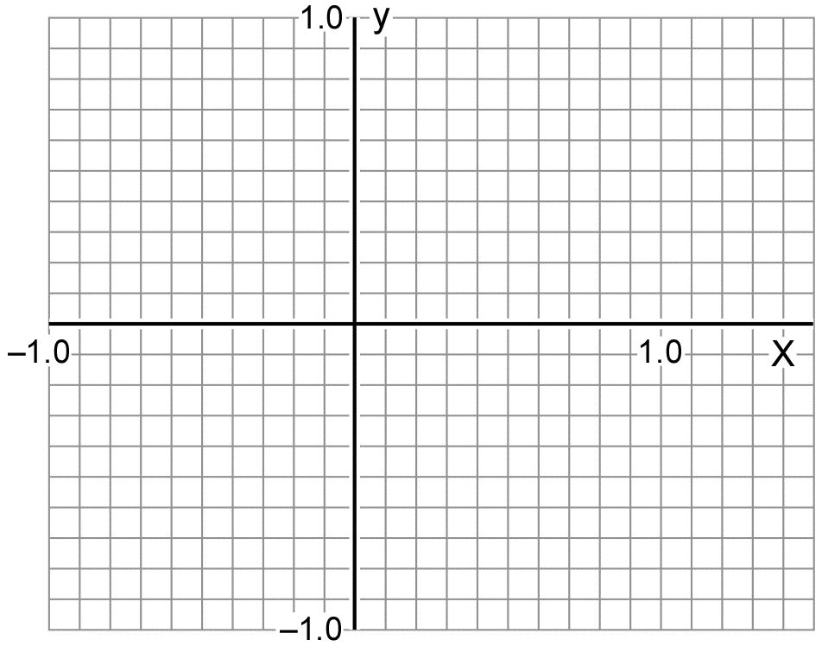

9. Using vectors *a* and *b* as specified in problem 8, accurately draw the vectors and graphically solve *a* – *b* on the graph above.

10. Using the vectors *a* and *b* specified in question 8 and given c = {-0.8, 0.6, 0}, what is the vector result of (*a* + *b* + *c*)? Find the sum arithmetically and graphically, using the space below.



11. What is the result of dot product  where *a* = {1.1, -0.3, 0} and *b* = {0.2, 0.5, 0}?

12. What is the angle between vectors *a* and *b*, as defined in question 11?

13. Given , what are the coordinates of *c*?

14. What is the length of *c*, as defined in question 13?