Finding location and velocity data for PBO GPS sites

Analyzing the velocities recorded at different GPS stations can give significant insights into plate tectonic motion, earthquake hazards, volcanic hazards, groundwater removal, and more.
GPS data can be acquired from a variety of different research groups around the world, but some the most accessible and easy to use GPS data comes from the EarthScope Plate Boundary Observatory (PBO), which is managed by UNAVCO and is available online for free at http://pbo.unavco.org/data. In this exercise you will learn one method for downloading GPS station location and velocity data.
Worked Example: Finding PBO GPS data near Lake Tahoe, California & Nevada
Finding station locations in latitude-longitude coordinates
Let’s search for data generated by one of the PBO’s permanent GPS stations near Lake Tahoe along the California-Nevada border. If we don't know which station we want to learn about, we can go to the interactive PBO map (https://www.unavco.org/instrumentation/networks/status/pbo/gps) and zoom-in on our area of interest. We find several green marker dots around Lake Tahoe, indicating stations that are functioning normally. Click on one just north of Lake Tahoe for some initial information. The dot we chose (Figure 1) is associated with station P150 (Martis Creek CN2008) located near Kings Beach on the north side of Lake Tahoe. Clicking on the dot gives us a box that provides
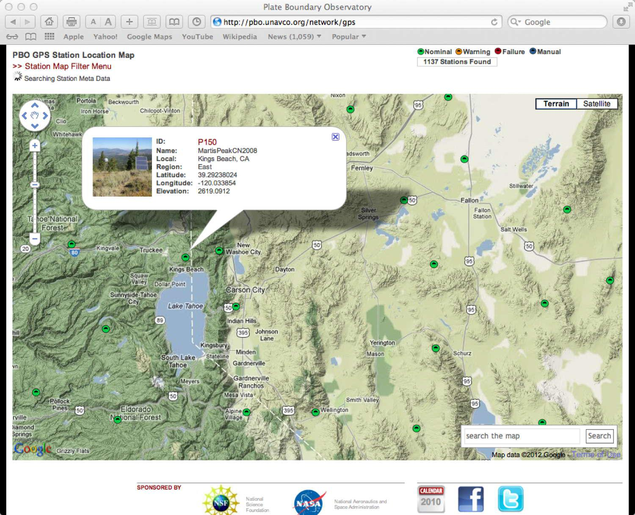
Figure 1. Interactive Plate Boundary Observatory station site viewer, zoomed to the area around Lake Tahoe. Inset window provides some data and a clickable link for more data about site P150. From https://www.unavco.org/instrumentation/networks/status/pbo/gps.
the name and location of the site, as well as a clickable link to more information at https://www.unavco.org/instrumentation/networks/status/pbo/overview/P150.
The overview page provides us with some information that we will need, and even some resources we might not need (such as a picture of the station) but is nice to have (Figure 2).
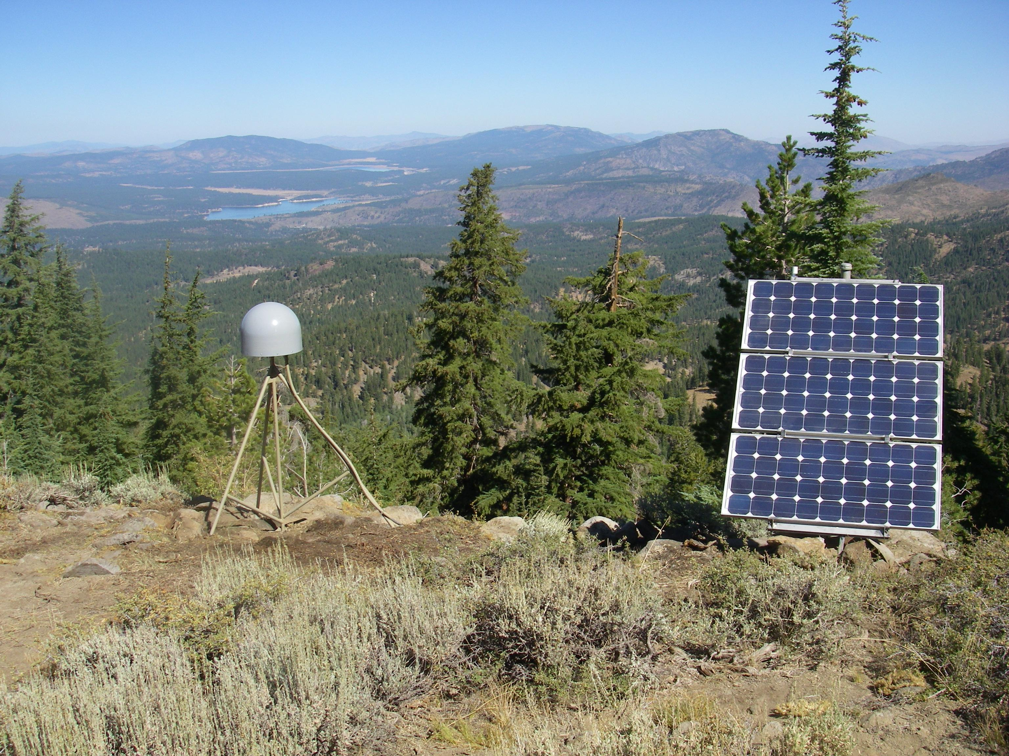
Figure 2. Plate Boundary Observatory Station 150 just north of Lake Tahoe. From https://www.unavco.org/instrumentation/networks/status/pbo/photos/P150
Near the bottom on the left side of the P150 overview page is a box titled “GPS Monument Coordinates.” Under the subtitle “SNARF Reference Frame,” the station location is listed on the line that begins “WGS 1984 lat/log/elev (d/d/m).” The first number is the site latitude with positive values indicating north latitude (geographic coordinate system in the WGS84 datum). The second number is the longitude, with negative indicating west longitude. The third number is the elevation in meters relative to the WGS84 ellipsoid – that is, it is not the elevation relative to mean sea level, as might be indicated on a USGS topographic map. On September 6, 2012, those data for site P150 were
latitude 39.292380625° (positive is north latitude)
longitude -120.033853528° (negative is west longitude)
elevation of 2619.0814 meters above the WGS84 datum.
Carefully record the latitude and longitude, with all of the decimal places. The sign of the longitude is important. These data will be part of the input for the strain calculator that we will use later in this process.
Finding station velocities
Now we need to acquire the velocity data for the site. Returning to the overview page for site P150, mid-way along the left side of the page there is a box labeled “Station Position” with three graphs. Clicking on the box causes the window to expand. The three plots show the change in position as a function of time – that is, they are time-series plots. The upper plot shows change in a north or south direction, the middle plot shows motion in an east or west direction, and the lowest plot shows motion in the up or down direction. These changes are measured relative to a reference frame that is computed relative to a set of GPS sites established in the stable interior of North America. That reference frame, fixed to the North American craton in areas unaffected by Neogene glaciation, is called NAM08.
You can switch from the raw data view to a “cleaned” view to a “detrended” view using either the navigation arrows on your keyboard or by using the small control bar that should appear near the bottom of the plot window. Both the cleaned and detrended plots provide a numerical estimate of the mean velocity in each of the three directions along with the corresponding uncertainty (Figure 3). These velocities are frequently updated as new data are collected. We can also access the daily position data in a CSV spreadsheet file, and compute our own velocities and uncertainties.
On 6 September 2012, the posted velocities were:
North 5.92 ± 0.03 mm/yr (positive value indicates motion toward north)
East -10.87 ± 0.03 mm/yr (negative value indicates motion toward west)
Height -0.93 ± 0.06 mm/yr (negative value indicates motion down)
We can use these data and the Pythagorean Theorem to find the total site velocity
mm/yr
and the site mean horizontal velocity
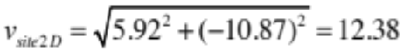 mm/yr.
Carefully record the velocities and their associated uncertainties. The signs of the velocities are important because they indicate the direction of the velocity vector. These data will be used along with the site latitude and longitude as input for the strain calculator later in this process.
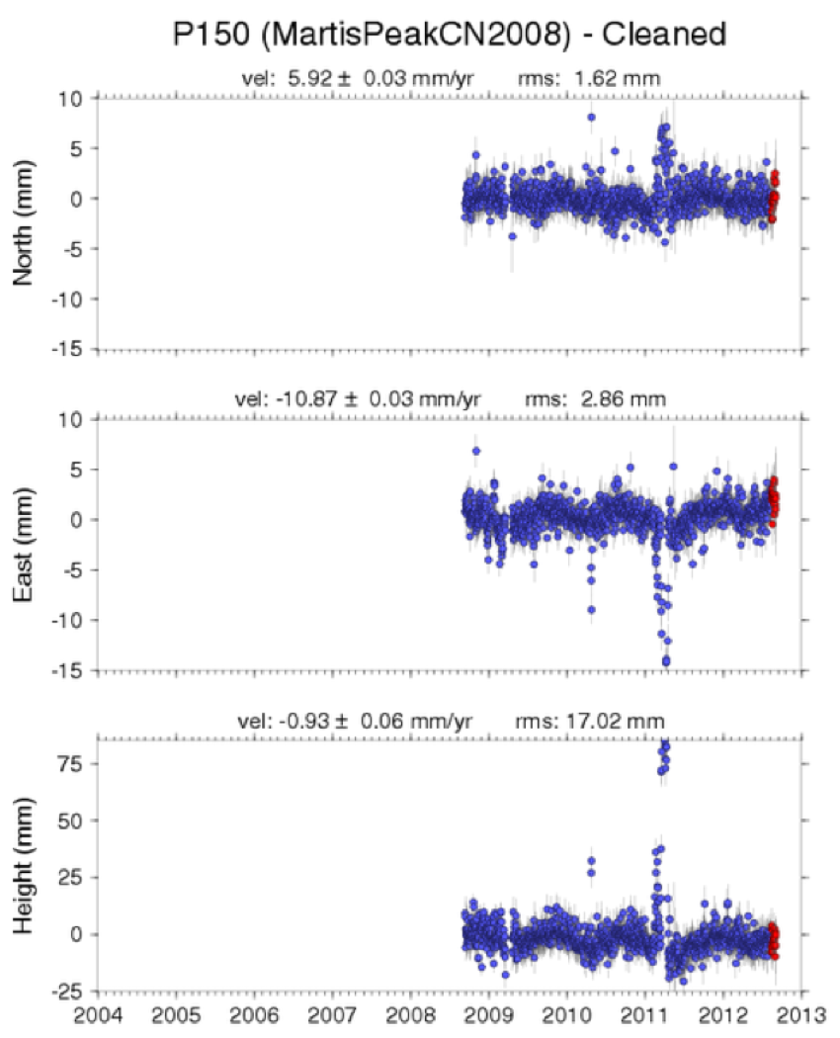
Figure 3. Static plot of cleaned and detrended time-series plots with interpreted velocities relative to the Stable North American Reference Frame (SNARF) from PBO GPS station P150. Accessed 6 September 2012 via https://www.unavco.org/instrumentation/networks/status/pbo/overview/P150.
Resources
Information about the EarthScope Plate Boundary Observatory is available online via http://pbo.unavco.org
General information about reference frames can be found at https://www.unavco.org/software/visualization/GPS-Velocity-Viewer/GPS-Velocity-Viewer.html
The Universal Transverse Mercator coordinate system is described at https://en.wikipedia.org/wiki/Universal_Transverse_Mercator_coordinate_system and https://pubs.usgs.gov/fs/2001/0077/report.pdf and https://gisgeography.com/utm-universal-transverse-mercator-projection/ among other references.
The National Geodetic Survey's NGS Coordinate Conversion and Transformation Tool (NCAT) is available via https://www.ngs.noaa.gov/NCAT/
Information about UNAVCO is available online via http://www.unavco.org/
The full public data holdings of UNAVCO are available via their "Data Archive Interface Version 2" at http://www.unavco.org/data/gps-gnss/data-access-methods/dai2/app/dai2.html. Information about the GPS-GNSS data holdings in particular is available via http://www.unavco.org/data/gps-gnss/gps-gnss.html

