Explanation of Strain Calculator Output Data
Original document by Vince Cronin (Baylor University). Revisions by Beth Pratt-Sitaula (UNAVCO).

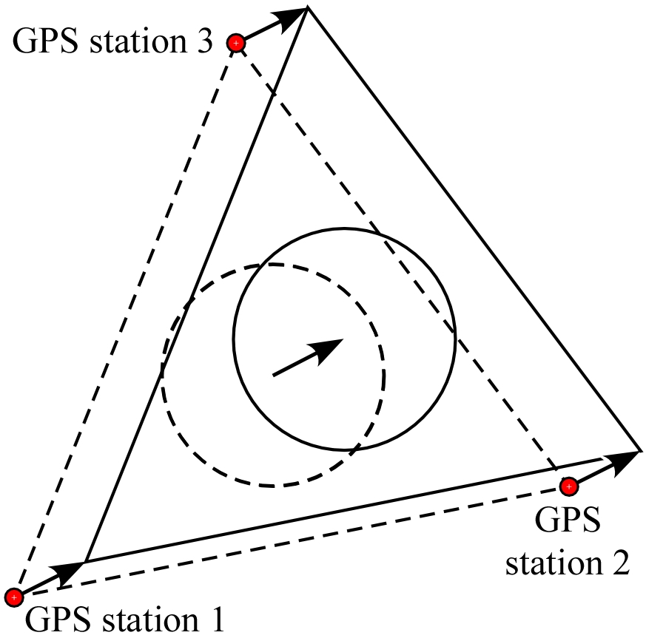
The “GPS Triangle Strain Calculator” (Excel and Matlab versions) takes the velocity at each of the three GPS stations, and determines what types of transformations the region between them is undergoing. breaks the total measured GPS velocities into components of the different types of transformations—translation, rotation, extension, and strain.
- The Translation Vector can be visualized as the vector from one specific point to another -- from the original position of the center of the triangle formed by the three GPS sites to the displaced position of the center of the triangle.
  - The East component of the translation vector is computed by taking the average of the three E (east-west) velocity vectors, expressed in meters per year (1 m/yr = 1000 mm/yr; 1 mm/yr = 0.001 m/yr). A negative value signifies westward movement.
  - In a similar way, the N component of the translation vector is the average of the N (north-south) velocity vectors, also expressed in meters per year; negative value is southward movement.
Figure 1. Translation.
  - The Azimuth of the translation is the average direction that the GPS sites are moving. The azimuth is measured in a horizontal plane, starting at north (0° azimuth) and rotating around in a clockwise direction. So, for example, a translation vector that is pointing due west has an azimuth of 270°.
  - The speed of the translation vector is the length or magnitude of the vector, expressed in meters per year. This is found using the Pythagorean theorem because the E and N components form a right triangle with the translation vector as the hypotenuse. If E is the E component, and N is the N component, then
speed =
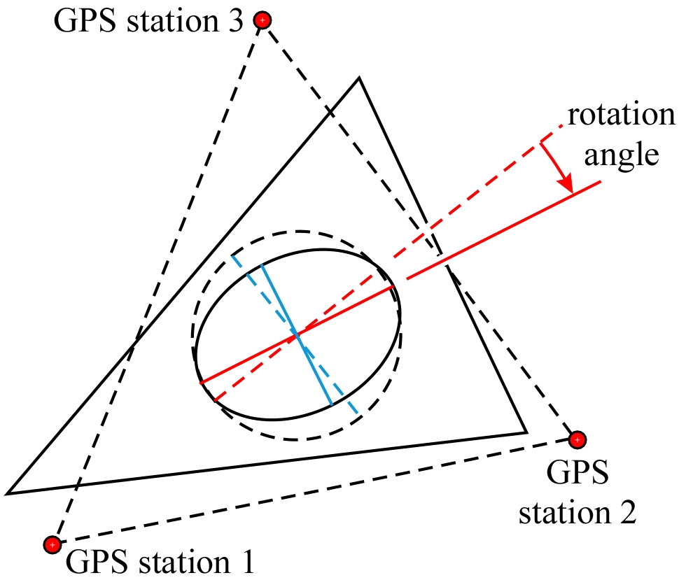
- The Rotational Velocity is given in both degrees per year and in billionth of a radian per year (nano-rad/yr), which is the unit that is more generally used for this work. As a result of the deformation that is reflected in the GPS site velocities, we can identify the major and minor axes of the horizontal strain ellipse (solid red and blue lines in the illustration at right). If we painted a line on the crust along the major and minor axes, and then reversed the deformation, those painted line would have changed their orientation a little bit (dashed red and blue lines). The change in orientation per year is the rotation that is given in the output. The direction of rotation is from the original orientation of a given axis and its orientation after deformation.
Figure 2. Rotation.
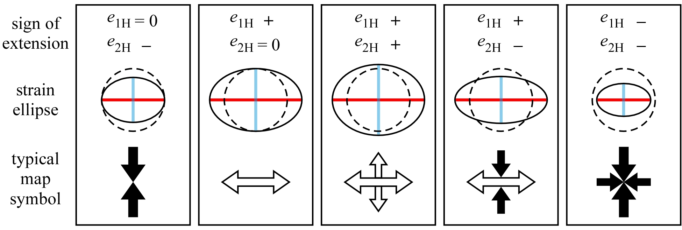
- The maximum and minimum horizontal extensions are measured along the longest and shortest axes of the strain ellipse, respectively. An extension is defined as (l_{f} – l_{o})/ l_{o}, where l_{f} is the final length and l_{o} is the original length. Strictly speaking, extension is a dimensionless number because it is a ratio of length to length. The units in "length over length" cancel each other out. For convenience, we use the word "strain" as a sort of imaginary unit of extension: l_{o} / l_{o} = 1 strain. The extensions we measure between GPS sites are billionths of a strain, expressed in nano-strain.
Imagine that we paint a big circle with a radius of 1 on the crust within the triangle formed by our GPS sites. A year later, that circle will be an ellipse, although it would be difficult for us to tell because the change would be so small. If the distance from the center of the ellipse to the most distant part of the ellipse (measured along the major axis) is greater than 1, then e_{1H} is a positive number. If the distance measured along the major axis is less than 1, then e_{1H} is a negative number. The value of e_{1H} is always greater than or equal to that of e_{2H} (the extension along the minor or smaller axis of the ellipse).
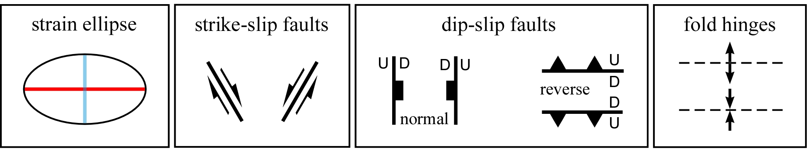
Figure 4. The infinitesimal horizontal strain ellipse shown at left above might be associated with present-day activity along strike slip faults oriented ≤45° to the (blue) minor axis of the strain ellipse, normal faults striking approximately parallel to the minor axis, reverse faults striking approximately perpendicular to the minor axis, or folding with hinge curves oriented approximately perpendicular to the minor axis. Which specific type of structure is more likely to be active depends on factors such as the relative magnitudes and signs of the principal extensions, the relevant characteristics of the upper-crustal materials present, and existence and characteristics of pre-existing structures (if any).
Figure 3 illustrates five possible outcomes, along with a typical map symbol associated with each outcome. The dashed curves trace the original circles that were distorted into the ellipses shown with solid curves, with S_{1H} axes indicated by red lines and S_{2H} axes in blue. Map symbols typically show black-filled arrows indicating contraction and white-filled arrows indicating stretching.
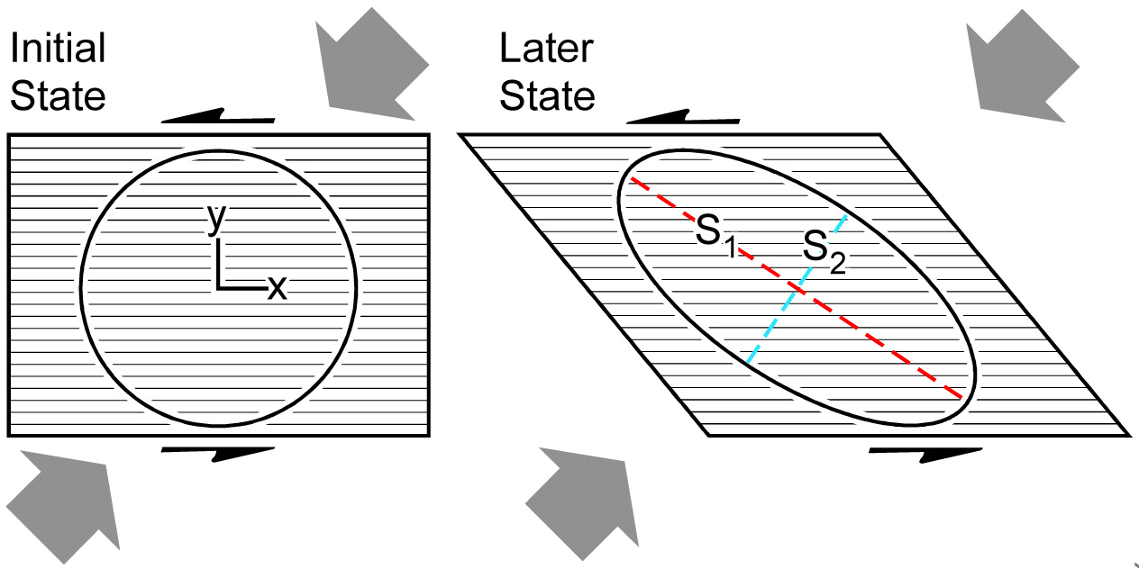
- The maximum shear strain is measured 45° from the maximum horizontal strain axis, and is equal to the difference e_{1H} – e_{2H}, measured in nano-strain.
Figure 5. Shear strain.
- The area strain reflects the change in area (if any) during distortion, and is equal to the sum e_{1H} + e_{2H}, measured in nano-strain. A positive value of area strain indicates that the area has increased, and a negative indicates that the area has decreased. The example here is homogeneous negative dilation, but many other possible changes in area are possible.
Figure 6. Area strain.

